CURRICULUM VITAE

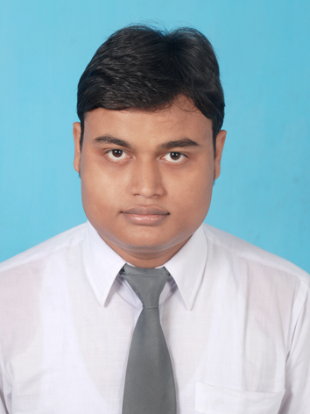

Address: S/o Pranabesh Chakraborty,
Block-D, Scheme-II, Flat-14,
H.I.T Qtr, Ichapur, Domurjola,
Howrah=711101
Mobile No: 9830971314
Email: animesh.chakraborty4@gmail.com
Animesh Chakraborty

Carrer Objective: To be a valuable part of an esteem organization like yours and to achieve its common goal through constant development process.

Career Summary:
- Innovative, Highly motivated, detail-oriented and goal-focused results-driven marketing professional with experience in both B2B and B2C segment.
- Demonstrated ability to achieve targeted goals and proven leadership, communication and negotiation skills.
- Capable of creative problem solving, with a keen attention to detail and quality.
- Independent worker with a high degree of initiative and motivation to serve client needs.

Work Experience:

- Working as Manager-International Business Development at Ovenite Express Ltd from
8th December, 2014- Till Date
- Worked as a Marketing Executive at A.R&C.INC & J.L.Goward&Co from 1st December,2013 -
31st October, 2014.
- Worked as an Executive Marketing & Sales in Capricans Aqua Pvt. Ltd. from
22nd April, 2013 – 26th November, 2013.

Roles & Responsibilities:

- Develop and maintenance of direct and indirect international business of East Zone.
- Maintaining relationship with existing clients and generation of business out of them.
- New franchise development.

Achievements:
- Got promoted to Manager-International Business Development for Eastern Zone on April, 2016.
- Achieved the highest international sale for Eastern Zone.
- Got promoted to Asst. Manager-Business Development for Howrah & Hooghly
on November,2015.
- Increased our organization’s brand visibility in Howrah and Hooghly.
- Doubled the base sale of Howrah and Hooghly.
- Expansion of company’s network in Howrah and Hooghly.

Education:

Year | Board/University | Course | Institution | Percentage/Grade
2013 | WBUT | M.B.A | Brainware Group Of Institutions | 7.15
2010 | Sikkim Manipal University | B.C.A | Sikkim Manipal University | 75.38
2007 | I.S.E | Science | ST. Thomas’ High School | 56.43
2005 | I.C.S.E | Science | ST. Thomas’ High School | 69.84

Area of specialization:

Major: Marketing.
Minor: Human Resource.

Internship/Projects Undertaken:

1) Project Title: Survey and analysis of retail penetration of FMCG products (Pepsodent vs. Colgate)

Tenure: Two months.

Key learning:
- Practical knowledge of activities in FMCG Market.
- Knowledge of Varied Consumers’ preference
- Techniques of market capturing.

2) Project Title: Demand Analysis Of Adams Elevators in Kolkata

Tenure: Two months.
Key learning:
- New Technologies in vertical transport industries.
- Techniques of corporate selling.
- Complexity of the market.

Other Achievements:

- Stood 1st in Maggie Quiz Contest.
- Got 1st division in painting under Bangiya Sangeet Parisad.
- Stood 2nd in All India Camel Colour Competition.
- Participated in SAARC Youth Festival.
- Stood 3rd in School’s Annual Sports.
- Represented college at The Great Mind Challenge Organized by IBM.

______________________________________________________________________________

Personal: Date of Birth : 12th February, 1989
Marital Status : Single
Languages : English, Bengali, Hindi.
IT Skill Set : MS Office, Internet, Basic Computer, DBMS
Driving license no : WB-1120080028092
Passport no. : M4390885
Hobbies : Playing guitar and writing songs.
_________________________________________________________________________________

Date: Signature:

